|  |  |  |  |  |  |  |  |  |  |  |  |  |  |  |
| --- | --- | --- | --- | --- | --- | --- | --- | --- | --- | --- | --- | --- | --- | --- |
| **MAD Project Evaluation 2 – Regular Intake 2021** | | | | | | | | | | | | | | |
| **Project Name:** |  | | **Batch:** |  | | | |  |  |  |  | | |
| Student ID | Student Name | Integrated system using a repository (Out of 5) | Marketing the app using a video clip published in a social media account (eg: LinkedIn) (Out of 10) | CRUD Function completeness (Out of 20) | Database connectivity (Out of 5) | Usability (Out of 5) | Validations (Out of 5) | Good coding practice (Out of 5) | Out of box features (Out of 10) | Test cases (Out of 10) | Report (Out of 10) | Q & A (Out of 15) | Total (Out of 100) |
| IT20005580 | G.A.M.T.S.B Amarakoon |  |  |  |  |  |  |  |  |  |  |  |  |
| IT20045326 | Dodanduwa D.L.H.S.D. |  |  |  |  |  |  |  |  |  |  |
| IT20055530 | H.M.T.D Dharmakeerthi |  |  |  |  |  |  |  |  |  |  |
| IT20121488 | Dissanayaka Y.D.N.N. |  |  |  |  |  |  |  |  |  |  |
|  |  |  |  |  |  |  |  |  |  |  |  |

Git Repository Link: https://github.com/Thimira99/MotroxApp/tree/thimira

Link for the video in social media: https://drive.google.com/drive/folders/1bN_O5f-bu8NtUCyTCr-KtcXagTu1QxvQ?usp=sharing

(All group members must be tagged)

----------------------------------------------------------------------------------------------------------For Evaluators--------------------------------------------------------------------------------------------------------Evaluator’s name:

Comments:

**Introduction To the Project**

Motorox Automobiles is one of the best automobile workshops in Moratuwa which offers large range of services for vehicles such as auto maintenance, system diagnosis and repair etc. Over 50 employees are working on multiple ramps.

Motorox is currently using a manual work for some management tasks. It has become difficult to achieve the expected effectiveness and productivity. In addition to that, paperwork need a significant amount of space and it is time consuming. Difficulty in modification of data is another drawback. Apart from that, the misplacement of documents can easily be happened, and it can cause lack of security.

Fully computerized system can be used to overcome above challenges faced by the current system. Therefore, they choose us to develop a web application and also client is willing to have more branches island wide in near future. Therefore, web-based application is the most suitable solution to accomplish the goals of Motorox.

IT20005580 – Booking Service Function

**Individual contribution graph**

**CRUD OPERATIONS**

**READ**

In this page users can book the service by click on booking service button. After click on that button, it display all the user details of those who have booked before.

**CREATE**

User wants to book a service user can click on add service button to navigate to the booking form.

**UPDATE**

If user need to update data, user can click that particular user detail in the list and it will display all the details in a new form.

User can edit their details in particular field and after click on update service button it will display the toast message like ‘Update successfully’.

**DELETE**

If user needs to delete the booking , user can delete their detail by click on delete button.

**Calculation**

When user needs to check their vehicle mileage before selecting the service type, users can click on calculate mileage button and calculate their vehicle mileage.

IT20121488 – Customer registration/ Customer profile

**Individual contribution graph**

**CRUD OPERATIONS**

**CREATE**

If a new customer Wants to login the application, customer can click on the customer login button. Then customer has to click on signup button. Then customer can make a new customer account.

**READ**

If customer wants to see his profile ,then customer has to click on the profile button. Then he/she can view details.

**DELETE**

IF customer needs to delete account, then the customer need to click on delete account button. Then the

Profile details will be deleted.

**UPDATE**

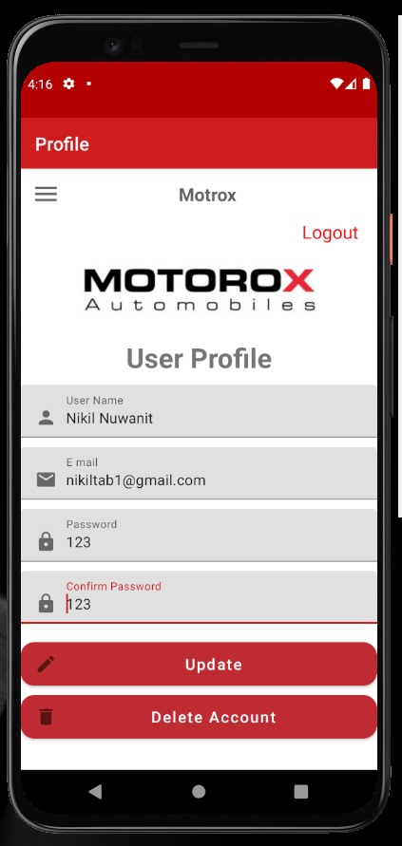IF customer needs update the account , then he/she needs needs to add new details and the details will be updated.

IT20055530 – Store and Add to cart Management

**Individual contribution graph**

**CRUD OPERATIONS**

**CREATE**

If user wants to order any item from the store. User can fill the form and confirm the order.

READ

This page display all the user details of those who have ordered before.

UPDATE

If user needs to Update any item that inserted can edit from here.

**IT20045326 – Manage Admin all Functions**

**Individual contribution graph**

SNAPSHOTS OF MY ADMIN FUNCTIONS

Calculation

Login,update,Delete

Contribution Graph

Commit List

